ChBE 6745 – Group 6 Project definition
Github: https://github.com/yship1002/ChBE-DataScience-Group6
Hazardous materials incidents dataset – To develop a classification model to predict damage severity with a balanced accuracy score greater than 0.6
Background:
The US pipeline and hazardous materials safety administration (PHMSA) collects detailed incident reports of hazardous materials (hazmat) transport accidents in the U.S. These reports contain structured data on incidents which includes the type of material, quantity released, package type, and damages incurred. From the perspective of chemical engineering, understanding and mitigating financial loss due to hazmat incidents is important. By analyzing this data, we can better predict the financial severity of incidents based on incident characteristics – potentially improving packaging, transport safety, and risk mitigation strategies.
Project goal:
The goal of this project is to develop a classification model that predicts the financial severity of hazmat transportation incidents (low, medium, high). The model’s performance will be evaluated using a balanced accuracy score with 0.6 being our target.

Strategy
Our strategy focuses on developing a classification model for predicting the severity of damage resulting from hazardous material incidents. We will preprocess the dataset by aggregating multiple rows per incident, cleaning missing values. Categorical features such as transportation mode, hazardous class, and packaging type will be encoded, while continuous features like quantity released and estimated speed will be standardized. Initial modeling will use the KNN model as a baseline model since it is relatively easy to implement. If the baseline model is not satisfactory, more advanced models such as decision trees, random forests, or even neural networks will be used. Model performance will be evaluated using a balanced accuracy score since the target variable is unbalanced.

Potential Risks
Several risks may affect the project. First, data quality issues (missing or inconsistent entries, mixed data types) may require significant data cleaning. Second, the distribution of damages is heavily skewed, creating a highly imbalanced classification problem. Third, high-cardinality categorical variables (e.g., carrier names, shippers) may lead to sparse encoding. Training and tuning tree-based models may require significant computation, particularly with high-cardinality categorical variables. Finally, advanced models like random forests and neural nets may offer higher accuracy but provide limited transparency for stakeholders who need explainability for safety or regulatory purposes.

Dataset Description:
For this project, we will use the Hazardous Materials Incident dataset obtained from the U.S. Department of Transportation’s PHMSA records. The dataset contains 10,237 incidents with 201 features describing event details, including transportation mode, location, hazardous material type, failure cause, and financial impacts. The target variable is Total Amount of Damages, which aggregates material loss, property damage, and cleanup costs. The dataset (downsample_correct_columns.xlsx) is loaded using pandas. Rows with missing key fields such as “Incident State,” “Quantity Released,” and “Mode of Transportation” are removed to ensure data integrity. The “Date of Incident” column is converted into a datetime object, and its month is extracted to classify each incident by season. Similarly, the “Time of Incident” variable is categorized into time-of-day groups such as Morning, Noon, Afternoon, Evening, or Night. Invalid entries in the “Hazardous Class” column are filtered out, and redundant time-related columns are dropped.
We also perform standard preprocessing steps including handling missing values, aggregating multiple rows per incident, removing outlier, log-transforming the damage cost to address skewness and labeling them as ‘low’, ’medium’, ’high’ based on whether they are within 1 std. One-hot encoding is also applied on categorical features to prepare the data for modeling.

Baseline Model:
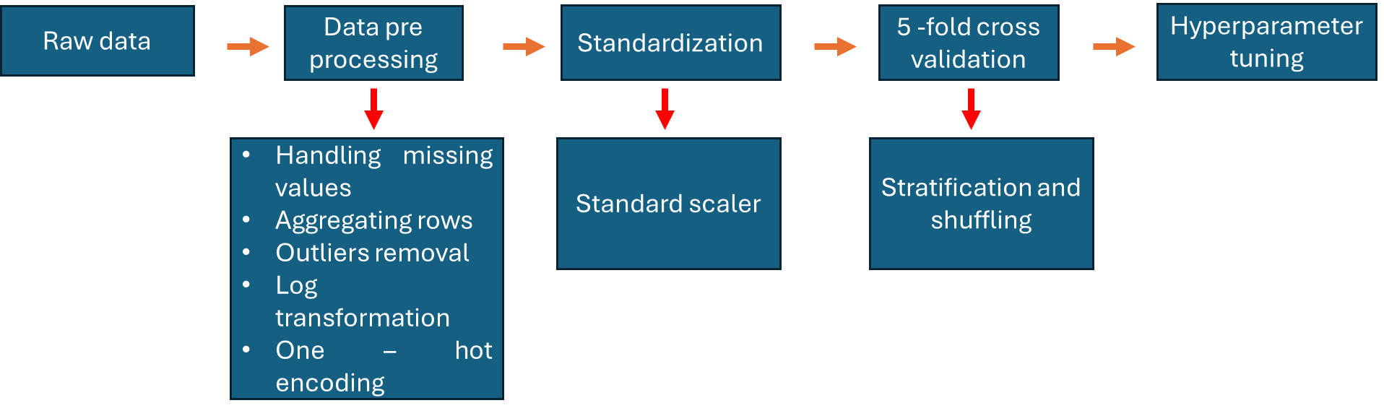
For the baseline model, a machine learning pipeline is created. This pipeline first standardizes all input features using StandardScaler, which centers each feature to have zero mean and unit variance. Standardization is essential for KNN because the algorithm measures distances between samples; if one feature has a much larger numeric scale than another, it will dominate the distance metric and bias the classification. After scaling, the standardized data is passed into the KNeighborsClassifier. To evaluate the model in a reliable and unbiased way, we set up a 5-fold stratified cross-validation scheme using StratifiedKFold. Stratification ensures that each fold has approximately the same class proportions as the entire dataset, which is especially important for imbalanced data. Shuffling is also enabled to randomize the samples, and a fixed random seed ensures reproducibility of the results. Then we perform hyperparameter tuning using GridSearchCV. The hyperparameter being tuned is the number of neighbors (n_neighbors) in the KNN model. The grid search tests multiple values—3, 5, 7, 9, 11, and 15—by training and validating the model in different folds. Each configuration is then evaluated using the balanced accuracy metric, which averages recall across all classes to prevent bias toward dominant classes. The grid search runs in parallel (n_jobs=-1) for efficiency. After the search is complete, the best-performing number of neighbors is identified. Once the best model is selected, predictions are generated using cross_val_predict. The balanced_accuracy_score for this baseline model is 0.45. Although it is below our target, this is a good start for a simple baseline model. The classification_report provides detailed precision, recall, and F1-scores for each class, giving deeper insight into how the model performs across categories. A confusion matrix is also plotted to visually display the number of correct and incorrect classifications per class.

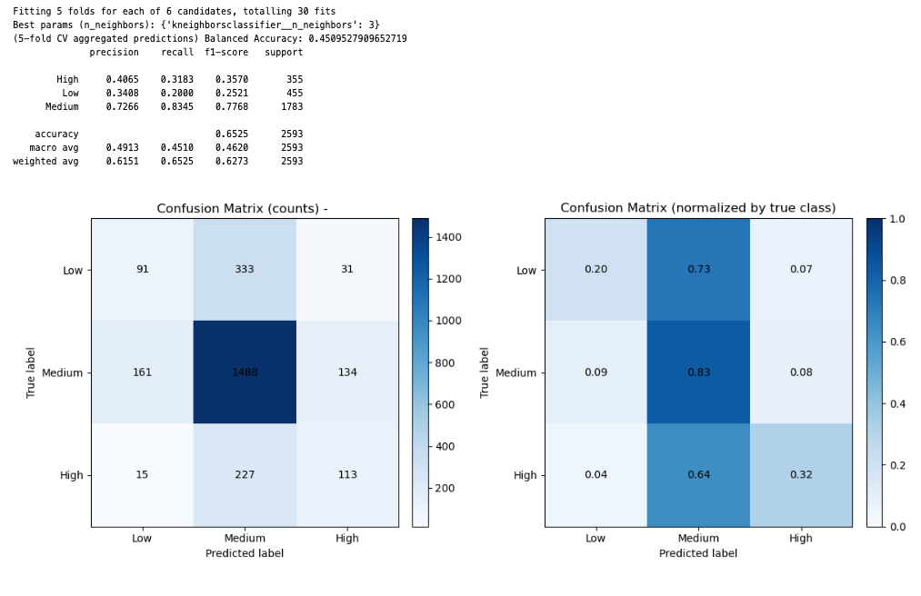
Improved model
We also tried more advanced models including Decision Tree and Random Forest. Again, we set up a five-fold stratified cross-validation process using StratifiedKFold. Next, two base classifiers are defined: a Decision Tree and a Random Forest, both configured with class_weight='balanced' to handle class imbalance automatically by adjusting the weight of each class inversely proportional to its frequency. Each model is associated with a parameter grid that specifies the hyperparameters to be tuned during training. For the Decision Tree, the grid includes variations of maximum tree depth, minimum number of samples required to split a node, and the impurity criterion (“gini” or “entropy”). For the Random Forest, in addition to these parameters, the number of trees (n_estimators) is also tuned. A grid search (GridSearchCV) is then performed for each model. Each model is then evaluated based on the balanced accuracy metric. After training, the best hyperparameters and the corresponding best cross-validation balanced accuracy are identified. Once the optimal model for each classifier is identified, predictions are generated using cross_val_predict. Like the baseline model, balanced accuracy score and confusion matrix are reported. Balanced accuracy score for decision tree is 0.6 while random forest is 0.66 which is above our target.
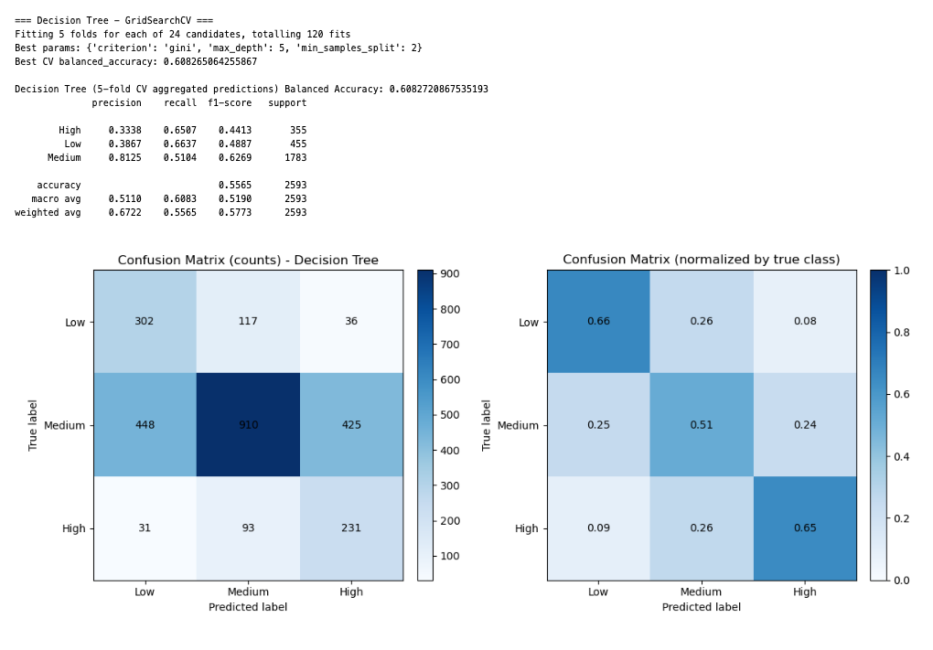
Although we achieved the target, we explored to see if neural networks could further improve the performance of the model. A lot of similar steps are performed here for the neural network model. To address potential class imbalance, we compute class weights using compute_class_weight instead, assigning higher weights to underrepresented classes. These weights are provided to the neural network during training so that the model pays equal attention to all classes. The neural network is built using Keras. It consists of an input layer matching the number of features, followed by two hidden layers. The first hidden layer has 128 neurons with ReLU activation, batch normalization, and a 30% dropout rate for regularization. The second hidden layer has 64 neurons with similar configuration and a 20% dropout rate. The output layer has three neurons with a softmax activation function, which outputs the probability for each class. The model is compiled with the Adam optimizer (learning rate 0.001), categorical cross-entropy loss, and accuracy as the evaluation metric. To improve training stability, two callbacks are used: EarlyStopping and ReduceLROnPlateau. EarlyStopping monitors the validation loss and stops training if it does not improve after 12 epochs, restoring the best weights. ReduceLROnPlateau reduces the learning rate by half when the validation loss stagnates for six epochs. The model is trained for up to 100 epochs, using a batch size of 32 and a 10% validation split. The computed class weights are applied during training to balance the influence of each class. After training, the model predicts class probabilities on the test set. The predicted class for each sample is determined by selecting the label with the highest probability. The predicted and true labels are then converted back from numeric form to their original string labels using the label encoder. The model’s performance is evaluated using a balanced accuracy score. Similar to previous models, a confusion matrix is plotted to visualize how well the model distinguishes between the three target categories. Unfortunately, the balanced accuracy score is 0.61, which is comparable to decision tree and random forest models.
